from sklearn.cluster import SpectralClustering
from numpy import random
import matplotlib.pyplot as plt
!pip install spectralcluster

#DATA
from sklearn.datasets import make_blobs

random.seed(1)
x, _ = make_blobs(n_samples=400, centers=4, cluster_std=1.5)
plt.scatter(x[:,0], x[:,1])
plt.show()

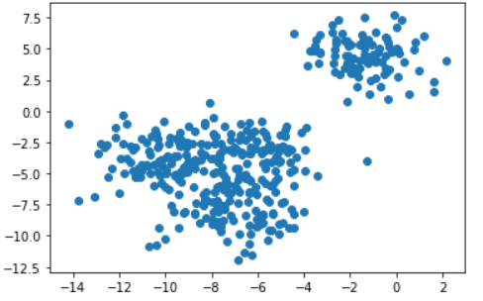
# SHOW WITH CLUSTERS 2,3,4,5

f = plt.figure()
f.add_subplot(2, 2, 1)

for i in range(2, 6):
sc = SpectralClustering(n_clusters=i).fit(x)
f.add_subplot(2, 2, i-1)
plt.scatter(x[:,0], x[:,1], s=5, c=sc.labels_, label="n_cluster-"+str(i))
plt.legend()

plt.show()

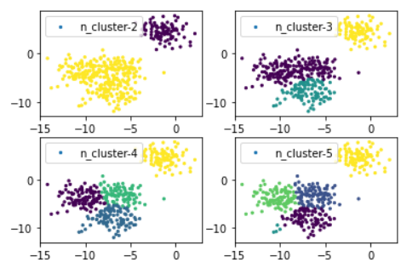

# 5 CLUSTERS
#===========
CC = 5
sc=SpectralClustering(n_clusters=CC).fit(x)

SpectralClustering(affinity='rbf',
assign_labels='kmeans',
coef0=1,
degree=3,
eigen_solver=None,
eigen_tol=0.0,
gamma=1.0,
kernel_params=None,
n_clusters=CC,
n_components=None,
n_init=10,
n_jobs=None,
n_neighbors=10,
random_state=None)
labels = sc.labels_

plt.scatter(x[:,0], x[:,1], c=labels)
plt.show()
print(sc)

